1. Which officer is assigned to the complaint filed?

select c.ComplaintID,c.CaseDesc,c.PoliceID,p.FName,p.LName from complaintmaster as c, policeinfo as p where c.PoliceID=p.PID;

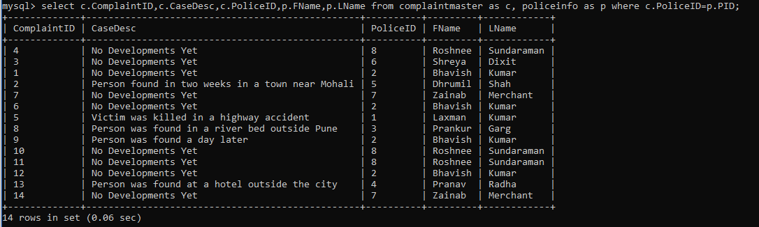

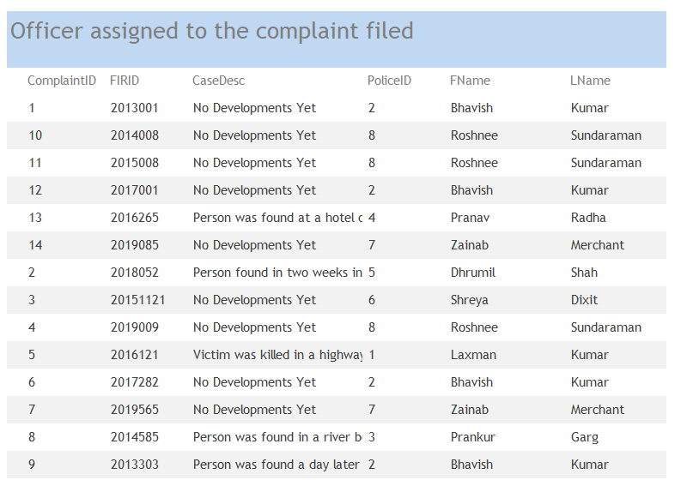

2. Whether the search operation is carried out or not?

Data where search operation is carried out.

select \* from complaintmaster where CaseDesc!="No Developments Yet";

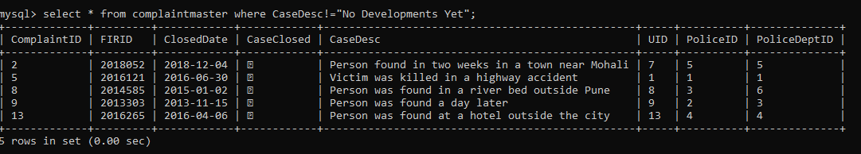

Query for report generation

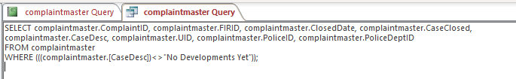

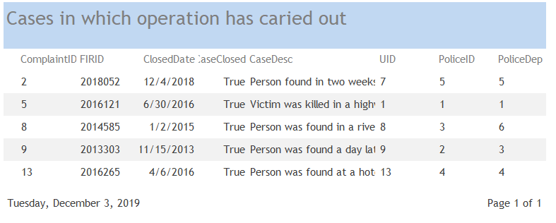

3. Which department has how many pending cases?

select c.PoliceDeptID,p.DepartmentName,count(c.PoliceDeptID) as "Count" from complaintmaster as c join policedepartment as p on c.PoliceDeptID=p.PDID where c.CaseClosed=0 group by c.PoliceDeptID order by count(c.PoliceDeptID) desc;

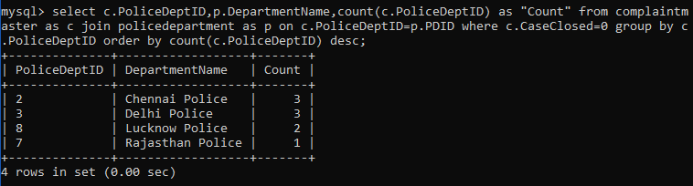

4. How many missing people are reported, by city and state?

Bycity

select city,count(ComplaintID) from missingpersoninfo group by city;

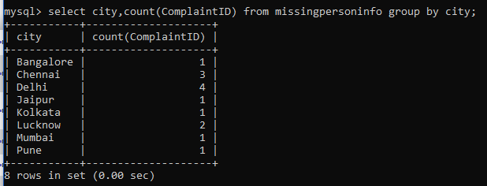

Bystate

select state,count(ComplaintID) from missingpersoninfo group by state;

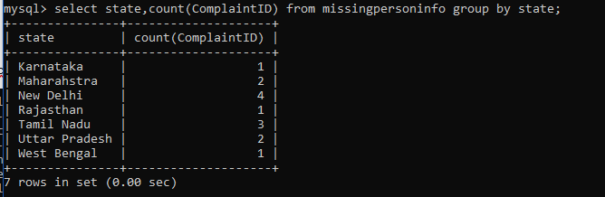

5. Which police department has the highest case solving rate?

select p.PDID,p.DepartmentName, ((select count(d.PoliceID) from policedepartment as t, complaintmaster as d where d.PoliceDeptID=t.PDID and d.PoliceDeptID=c.PoliceDeptID and d.CaseClosed=1 group by d.PoliceDeptID)/count(c.PoliceDeptID)) as “Case Solving Rate” from policedepartment as p, complaintmaster as c where c.PoliceDeptID=p.PDID group by c.PoliceDeptID

